Student Course Registration System

# **Background**

Student course registration systems are a type of software application designed to facilitate the process of student enrollment in academic courses. These systems are widely used in universities, colleges, and other educational institutions to manage the registration process for students.

In the past, course registration was often a manual and time-consuming process, requiring students to fill out forms and submit them to the registrar's office. However, with the advancement of technology, many educational institutions have moved to online registration systems, which provide greater efficiency and convenience for students and administrators alike.

Java is a popular programming language for developing student course registration systems because it is platform-independent, meaning that it can run on any operating system. Java is also known for its robustness and security, which are important features for any system handling sensitive student information.

A typical student course registration system built in Java would include a user interface for students to view available courses, select the courses they wish to take, and register for those courses. The system would also include an administrative interface for staff to manage course offerings, monitor enrollment, and generate reports.

The system would likely integrate with other institutional systems, such as student information systems and learning management systems, to ensure that all data is up-to-date and accurate. Security features such as user authentication and data encryption would also be essential to protect the system from unauthorized access or data breaches.

Overall, a student course registration system built in Java can provide significant benefits for educational institutions, including increased efficiency, convenience, and security in managing the registration process for students.

# **Problem Statement**

Many educational institutions still rely on manual course registration processes, which can be time-consuming and prone to errors. There is a need for a more efficient and accurate way to manage the course registration process for students. A student course registration system built in Java can address this need by providing a secure, user-friendly, and automated system for students and administrators to manage course enrollment. The system should be able to handle a large volume of students and courses while ensuring data accuracy, security, and integrity. Additionally, the system should integrate with other institutional systems to provide a seamless user experience for students and staff.

# **Proposed Solution**

User-friendly interface: The system should have a user-friendly interface for students to browse and select courses they wish to enroll in. The interface should provide information such as course descriptions, schedules, prerequisites, and available seats.

Automated enrollment: The system should allow students to enroll in courses automatically, based on their selected preferences and available seats. The system should also handle conflicts such as schedule overlaps or prerequisite requirements.

Administrative interface: The system should have an administrative interface for staff to manage course offerings, monitor enrollment, and generate reports. The interface should allow staff to add, modify, or cancel courses, as well as manage student enrollments and waitlists.

Integration with other institutional systems: The system should integrate with other institutional systems such as student information systems and learning management systems, to ensure that all data is up-to-date and accurate. The integration should be seamless and secure, ensuring that data is transferred and stored securely.

Security and data integrity: The system should have robust security measures such as user authentication, data encryption, and access control, to protect against unauthorized access and data breaches. The system should also ensure data integrity by preventing data duplication or loss.

Scalability: The system should be able to handle a large volume of students and courses, and should be scalable to accommodate future growth and changes in the institution's course offerings.

# **Experiments:**

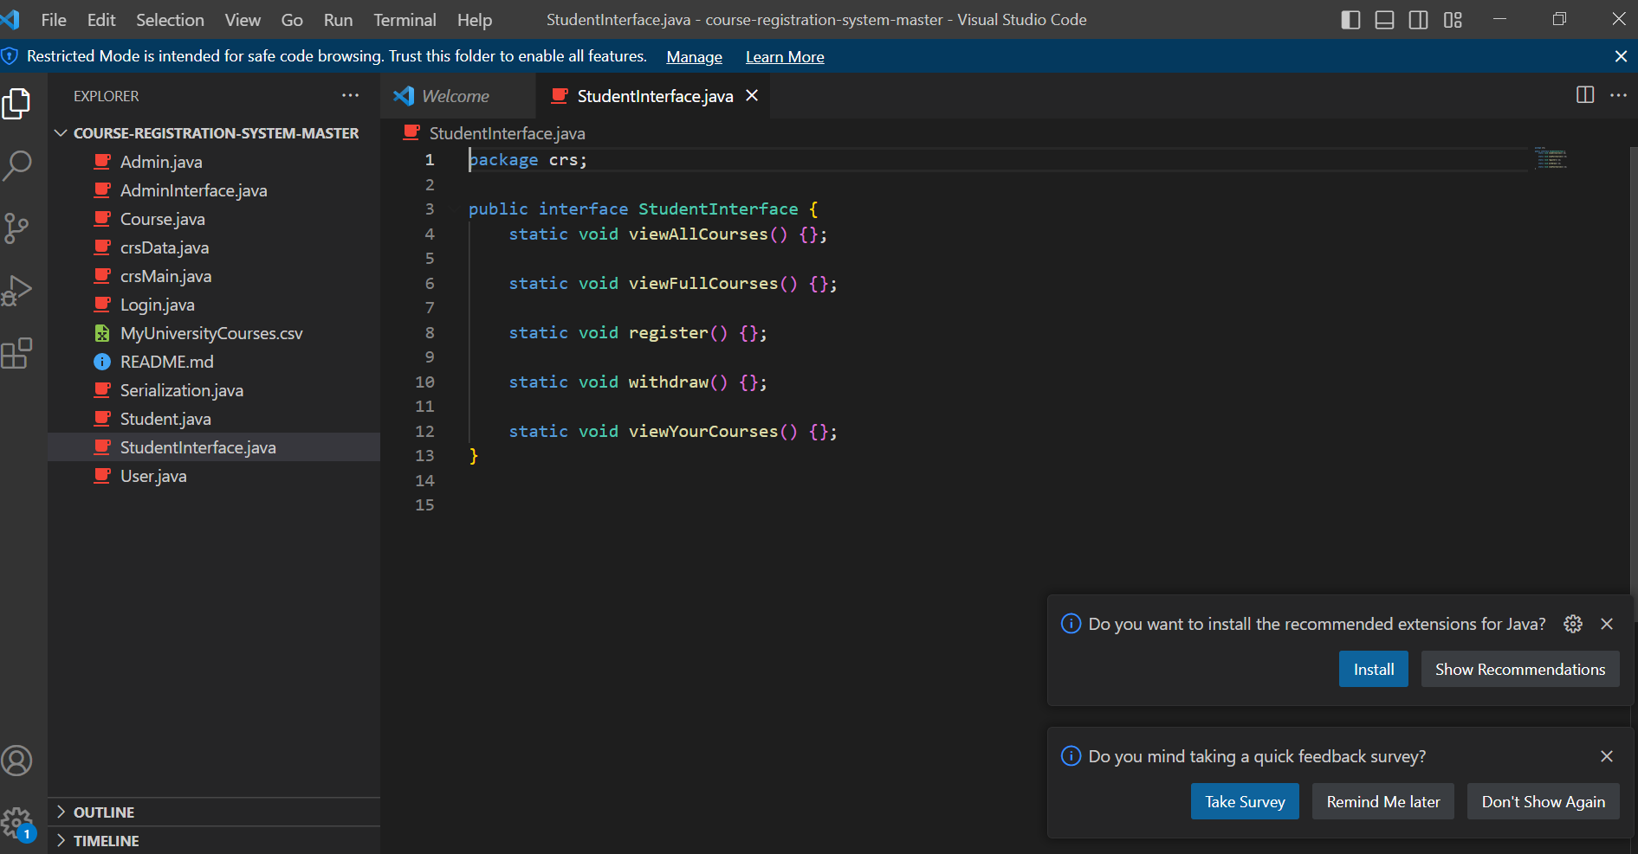

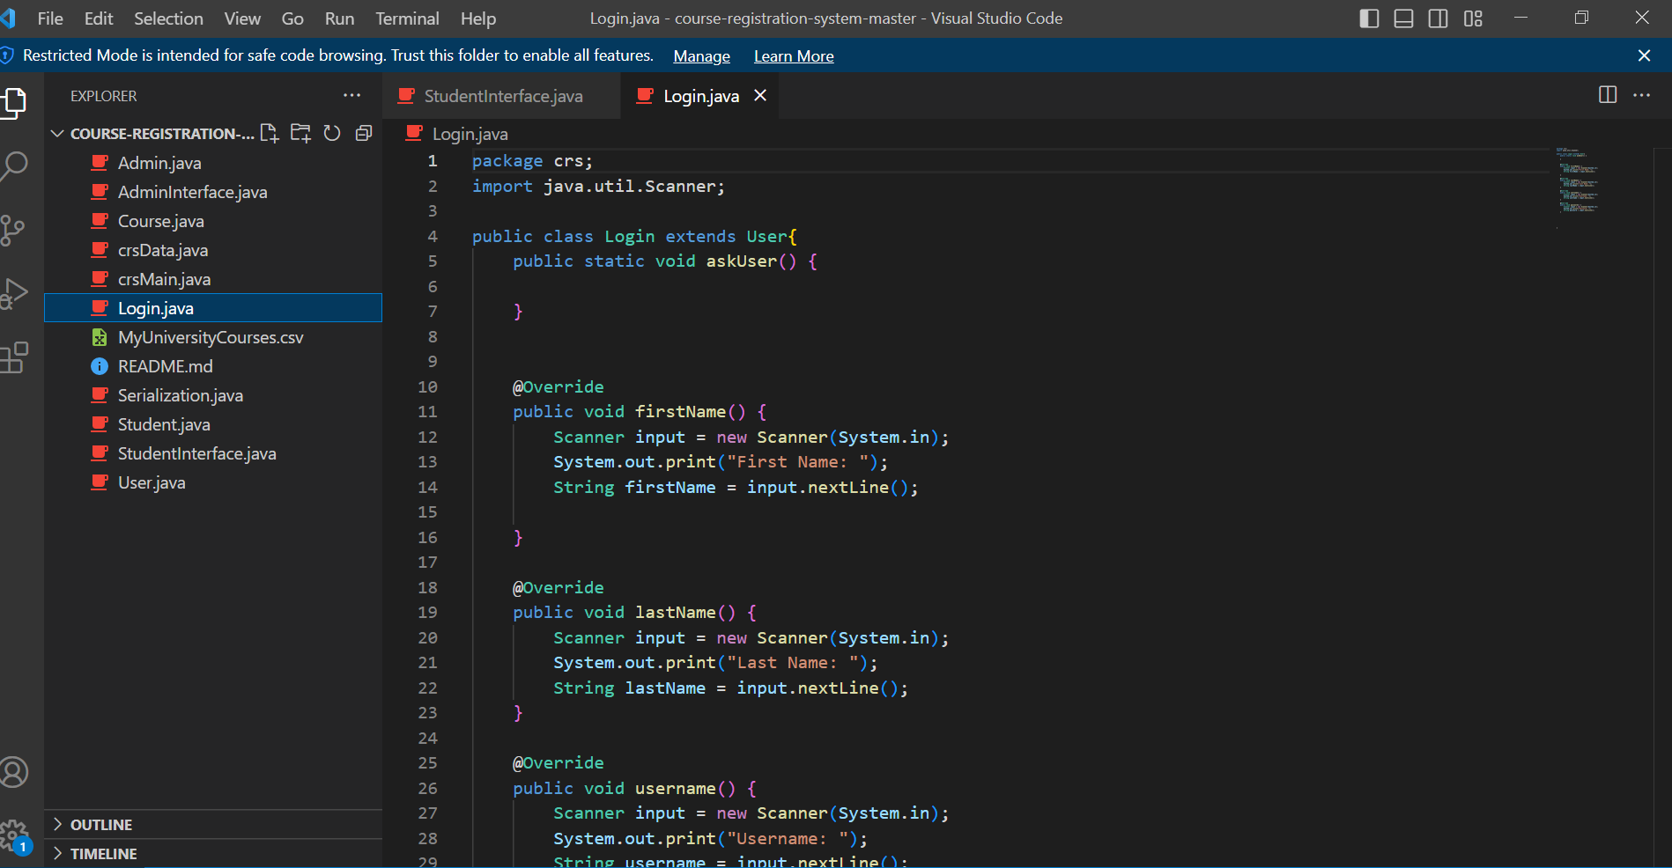

# **Results:**

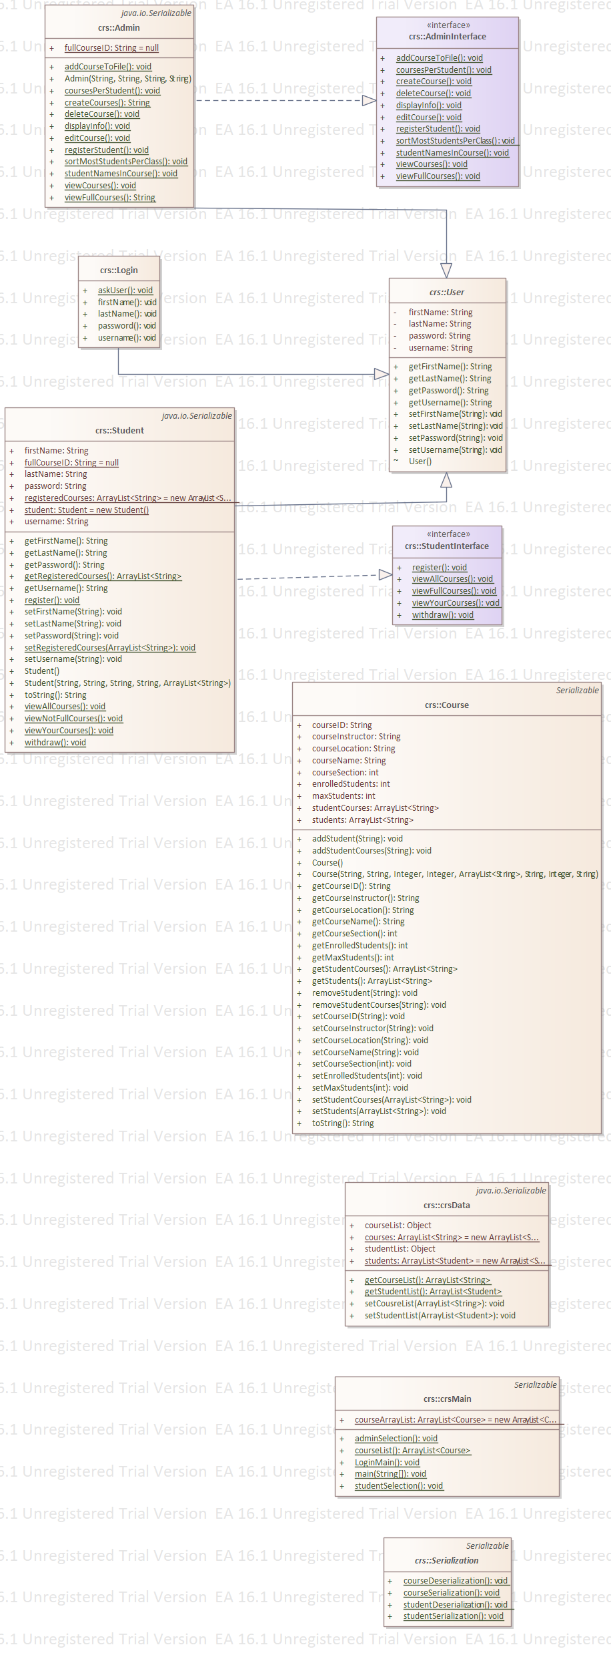

# **References:**